**SOP On Accounting Product Tracking System**

**Document Control**

**Version History**

|  |  |  |  |
| --- | --- | --- | --- |
| **Version Detail** | **Date** | **Prepared By** | **Reviewed By** |
| V1 | 18/08/2023 | Ritesh Nagdive | Usama Mashayak |
| - | - | - | - |

# Table of Contents

Table of Contents 3

1. Introduction 4

2. Architecture of APT 5

3. Flow Diagram of APT Servers 6

4. E-link Application 7

5. Working Structure 7

|  |  |  |  |
| --- | --- | --- | --- |
|  |  | |  |
|  |  | |  |
|  |  | |  |
|  |  | |  |
|  |  |
|  |  |

# Introduction

We have our own Application & Product tracking System Software (APT). Product Tracking System is a software application facilitating real-time tracking from the manufactured product to warehousing products and shipping which provides complete control about products management and modify Status of product, reports about products. Functionalities like Receive, Store, Barcode Tracking, Delivery Tracking Reports, Sales order, Purchase order, and customer invoices Record, Vendor order, Billing record, order Form and many more.

# Architecture of APT

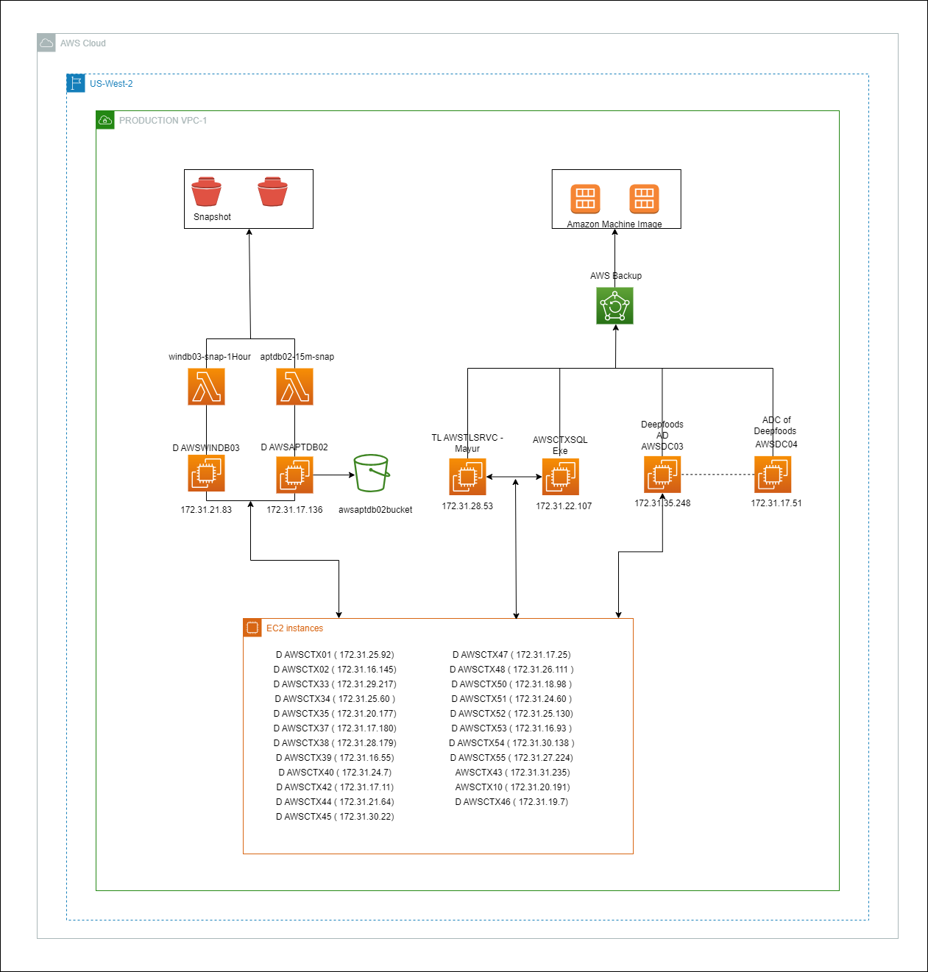

Figure 1: Domain Controller Server And APT Architecture

# Flow Diagram of APT Servers

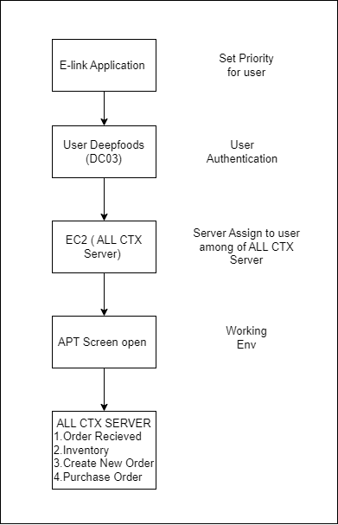

Figure 2: Flow Diagram of APT Server

# E-link Application

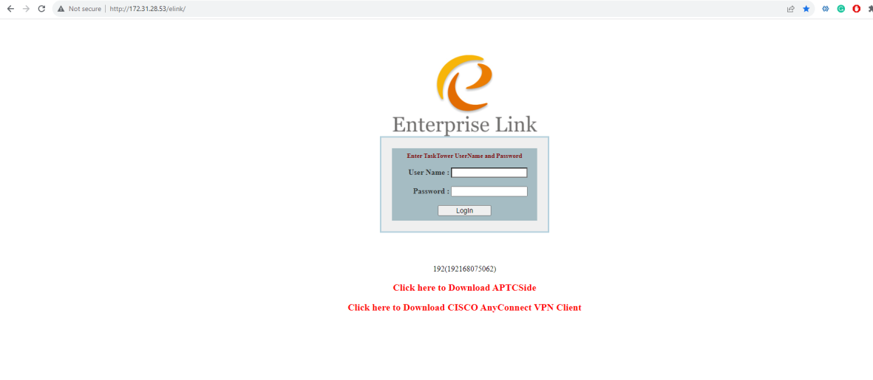

Figure 3: E-link Application

# Working Structure

1. The E-link Application is hosted on ( TL AWSTLSRVC – Mayur ) within the AWS Cloud us-west-2 region. A priority system has been implemented to regulate user access to the CTX server, ensuring an even distribution of user workloads across all CTX servers
2. We can view the Active or Inactive status of user on E-link Application. Mainly E-link Application using for balancing the load distribution for users. Also we can assign warehouses to the user according to requirement.
3. The AWSCTXSQL Exe server is utilized to store E-link Data within the SQL Database.
4. Authentication for users takes place on AWSDC03, an AD server. Users are then assigned to AWSCTX servers based on their designated priority for operational tasks.
5. A contingency plan is in place with AWSDC04, a replica of AWSDC03, which becomes active in case of any failures, ensuring continuous service availability.
6. We have taken a snapshot D Drive of AWSWINDB03 on every hour and APTDB02 on every 15 min by using AWS Lambda which provides data redundancy and backup.